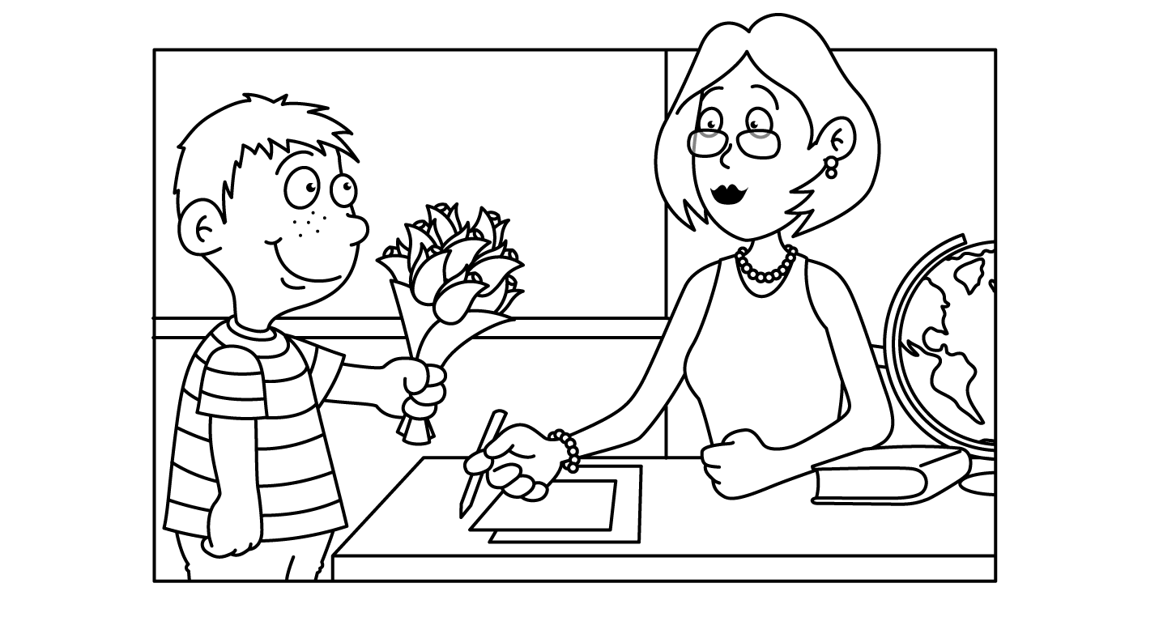

MONTH of MAY
Sunday | Monday | Tuesday | Wednesday | Thursday | Friday | Saturday
4/29/14 (p.1/3/5)  Standard 5  1. body organization lesson p.464-467  2. explore activity p.467  3. body organization & structure worksheet  (2 pages)  4/30/14(p.2/4/6)  SAME | 5/5/14  1. pre-test  2. ground rules  3.Lesson 1: Myths & Stereotypes Regarding Persons Infected with HIV  4. watch Ryan White DVD  HIV/STD Training  START | 5/6/14  Lesson 2: HIV Disease: Effects on the Human Body, Transmission Myths, and Facts | 5/7/14  Lesson 3: STD’s | 5/8/14  Lesson 4: Recognizing Risky Situations / Methods to Reduce Risk | 5/9/14  Peer & Media Pressures / Refusing Skills Practice
5/1/14(1,3,5)  Standard 5c  1. The skeletal system lesson p.468-471  2. review questions p.471 #1-4 in logs  3. worksheet p.67  NOTIFY Ss: Return textbooks on your own to the library start 5/1/14 | 5/12/14  1. Lesson 6: Community Resources / Personal Contracts  2. post-test  HIV/STD Training END | 5/13/14  Standard 5c  1. The muscular system lesson p.472-475  2. Quick lab p.473  3. Muscle map worksheet, p.68 | 5/14/14  1. Exercise your heart activity p.487  2. The cardiovascular system lesson p.488-489  3. Matchmaker worksheet p.71 | 5/15/14  Standard 5j  1. The cardiovascular system lesson day 2 p.490-493  2. Colors of the heart worksheet, p.72 | 5/16/14  Standard 5d, 5e  1. Human reproduction lesson, p.538-539  2. Math break p.539 #1-2
5/2/14(2,4,6)  SAME  NOTIFY Ss: Return textbooks on your own to the library start 5/1/14 | 5/19/14  1. Growth and development lesson, p.542-545  2. The beginning of life worksheet, p.82 | 5/20/14  Standard 5g  1. Eye lesson p.518  2. Pupil activity p.519  3. Quick lab “Where’s the dot?” p.520 | 5/21/14  Standard 5g  1. Ear lesson  2. “Inside the Ear” activity  scholastic.com/browse/article.jsp?id=3757140  option 2:  “Ear guitar” activity  https://www.exploratorium.edu/science_explorer/ear_guitar.html | 5/22/14  Standard 5/7  “Leaf me alone!” activity p.596 text | 5/23/14  Standard 6e/7  “Color subtraction”  Activity, p.569 text
Group Lab Set  “Observing Plant Growth” p.279  Period 1 or 2 set-up | 5/26/14  “Memorial Day”  No School | 5/27/14  Standard 7  1. “Shape Island” activity, p.593-594 text | 5/28/14  Minimum day  Yearbook signing | 5/29/14  Minimum day  Yearbook signing | 5/30/14  Last day of school  Yearbook signing

